Project Development Phase
Performance Test

Date | 10 February 2025
Team ID | LTVIP2026TMIDS35203
Project Name | Project - visualization tool for electric vehicle charge and range analysis
Maximum Marks

Model Performance Testing:
Project team shall fill the following information in model performance testing template.
S.No. | Parameter | Screenshot / Values
 | Data Rendered | 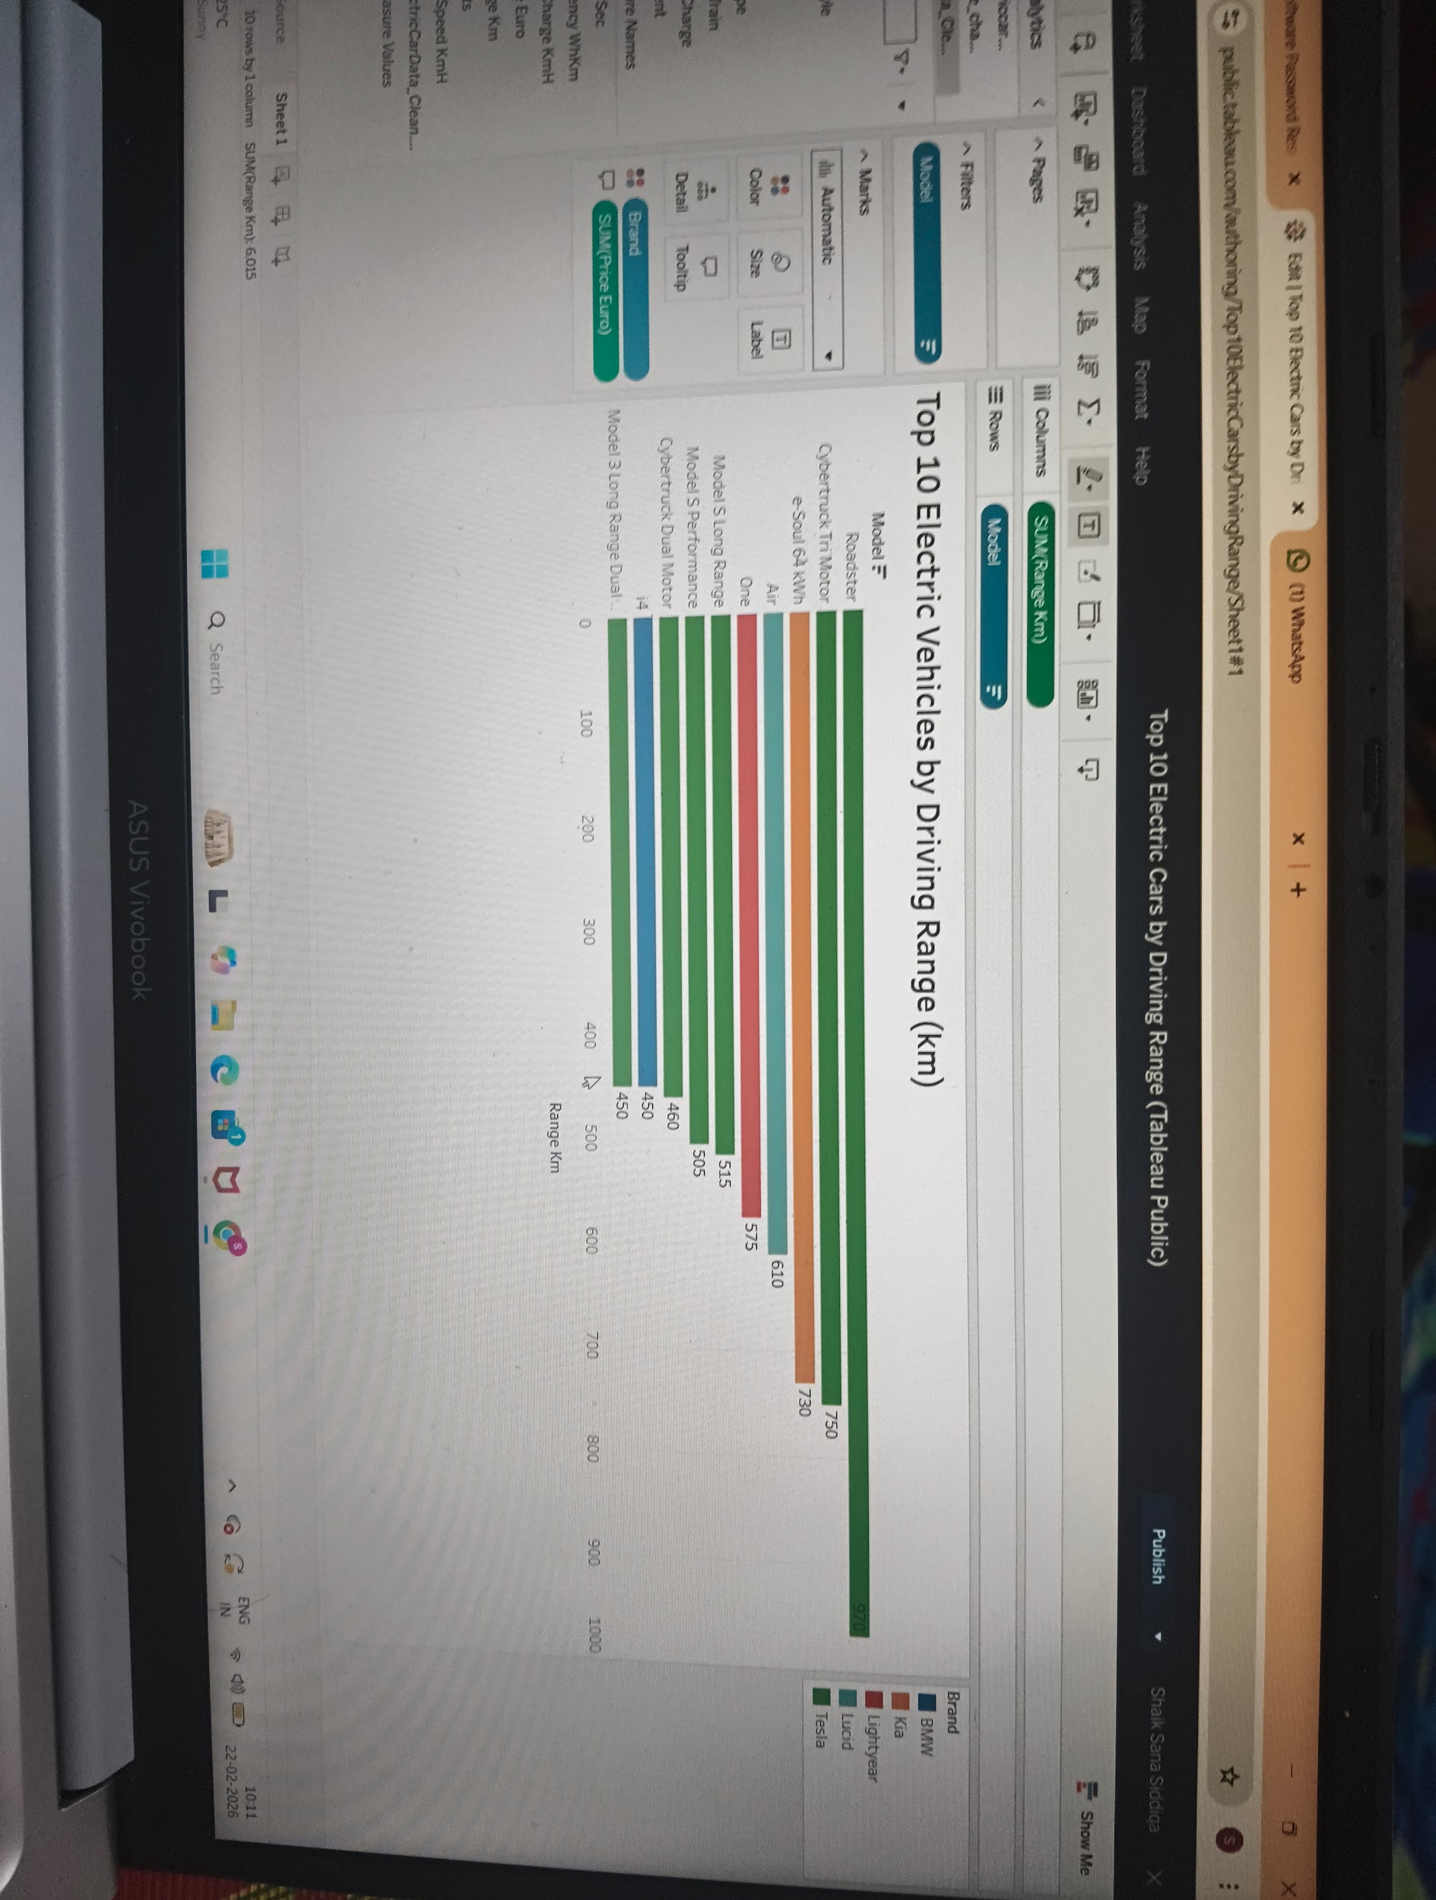
 | Data Preprocessing | 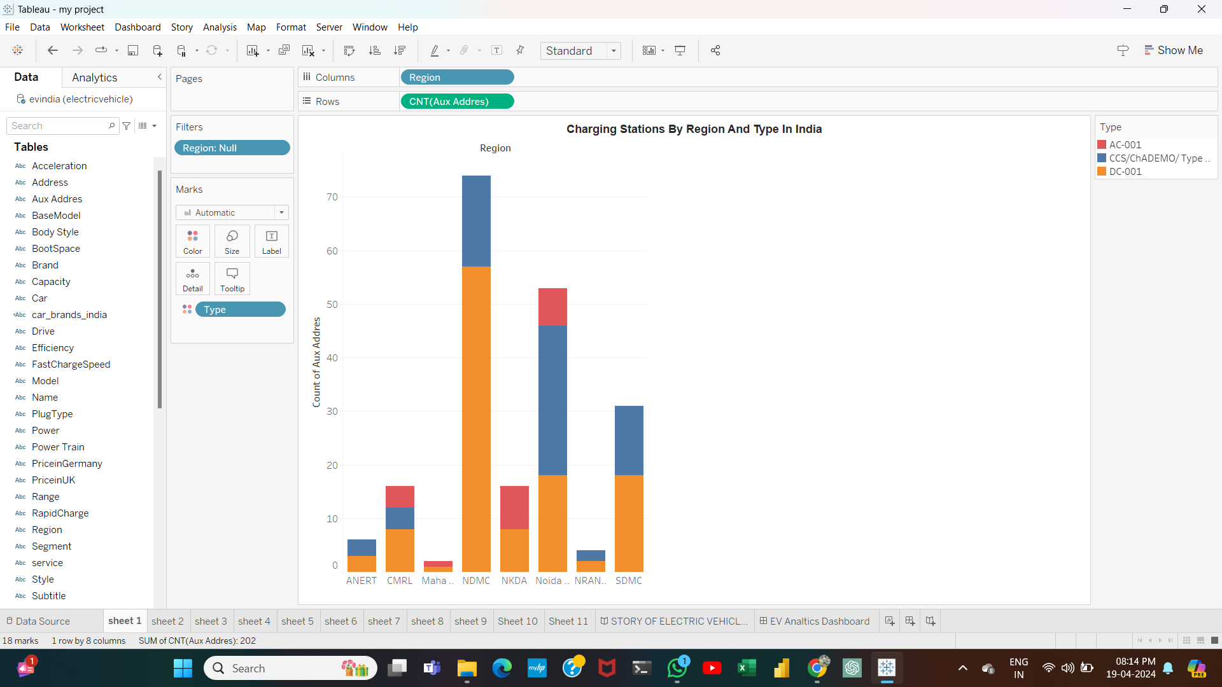
3. | Utilization of Filters | 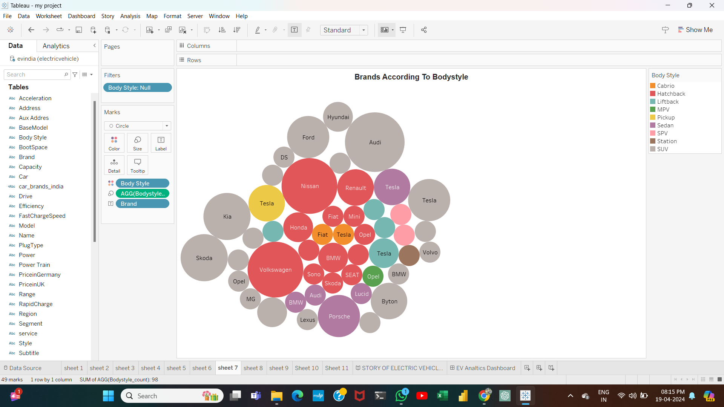
4. | Calculation fields Used | 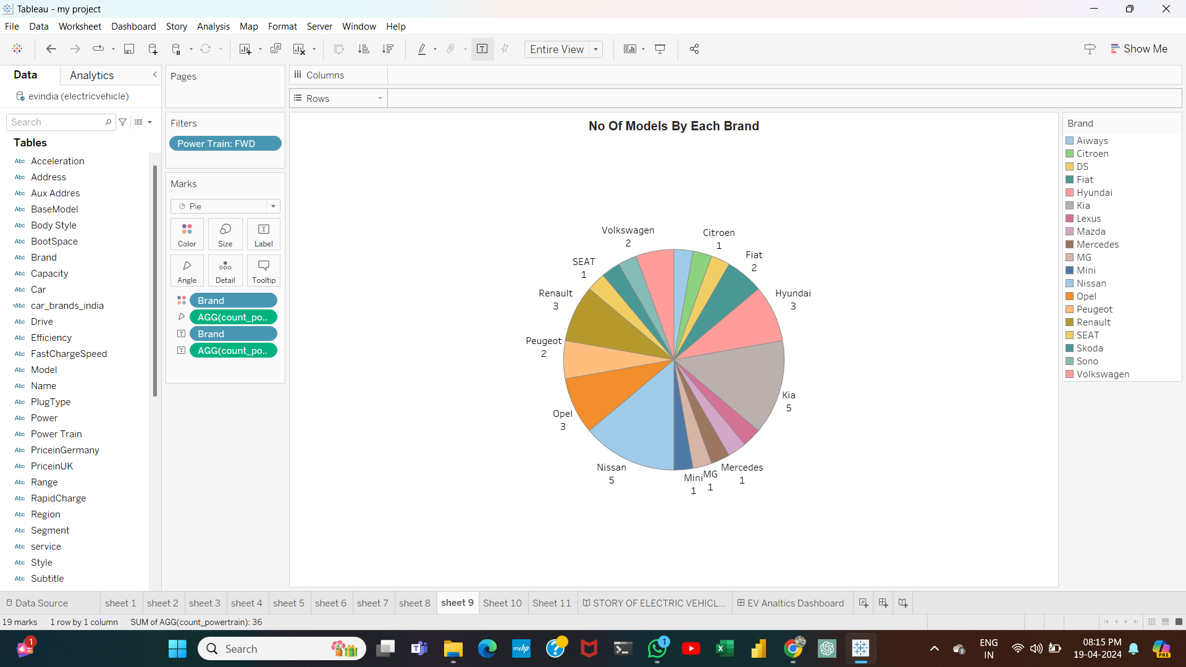
5. | Dashboard design | No of Visualizations / Graphs -
6 | Story Design | No of Visualizations / Graphs -

